- INTRODUCTION

Power quality is one of the most important topics that electrical engineers have been noticed in recent years. The main problems related to power quality are harmonic distortion and reactive power compensation. Most industries and companies prefer electrical energy with high quality. If delivered energy to these loads has poor quality, products and equipment of these loads such as microcontrollers, computers, motor drives etc are damaged. Hurt of this phenomenon in companies that dealing with information technology systems is serious. Nowadays, Custom Power equipments are used for this purpose. Until now, to filter these harmonics and to compensate reactive power at factory level, only capacitor and passive filters were used. More, new PWM based converters for motor control are able to provide almost unity power factor operations. We cannot depend on this capacitor to filter out those harmonics. This is one of the reasons that the research is being done in the area of Active Power Filter (APF) and less pollutant drive. Loads, such as, diode bridge rectifier or a thyristor bridge feeding a highly inductive load, presenting themselves as current source at point of common coupling (PCC), can be effectively compensated by connecting an APF in shunt with the load. The term harmonics referred to Power quality in ideal world would mean how pure the voltage is, how pure the current waveform is in its sinusoidal form. Power quality is very important to commercial and industrial power system designs. Ideally, the electrical supply should be a perfect sinusoidal waveform without any kind of distortion. If the current or voltage waveforms are distorted from its ideal form it will be termed as harmonic distortion. This harmonic distortion could result because of many reasons. In today’s world, prime importance is given by the engineers to derive a method to reduce the harmonic distortion. Harmonic distortion was very less in the past when the designs of power systems were very simple and conservative. But, nowadays with the use of complex designs in the industry harmonic distortion has increased as well.
This project explains the effects of Harmonics in the Power System and steps to reduce the effects of Harmonics. This project will also explain how Harmonic distortion is one of the most important problems associated with power quality and creates several disturbances to the Power System. It includes the harmonic reduction techniques to improve the power quality and it will also include the simulation for the same.
Now, more than ever advanced technologies are paramount for the reliable and secure operation of power systems. Power Electronic based equipment, such as Flexible AC Transmission Systems (FACTS), High-Voltage DC (HVDC), and Custom Power technologies constitute some of the most promising technical advancements to address the new operating challenges being presented today. These advancements are based on the high-performance capability of power electronic equipment to rapidly respond to system events, increase power transfer limits and improve the quality of power delivered.
The STATCOM is a shunt-connected reactive power compensation device that is capable of generating or absorbing reactive power. The output voltage of the STATCOM can be varied to control the specific parameters of an electric power system. The voltage source inverter (VSI), employing turn-off capability semiconductor switches, is an important part in the STATCOM because it can operate at high switching frequencies and provide a faster response.
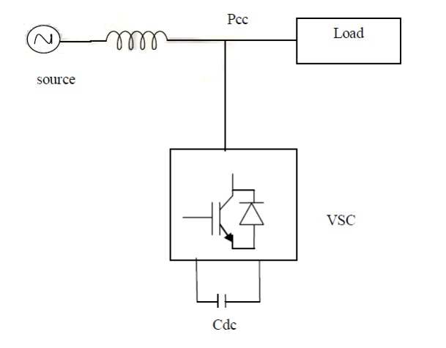
Fig.1.1 .The basic structure of STATCOM

Many studies show that the usage of STATCOM is effective to improve power and voltage quality problems. The control scheme for the operation of STATCOM under unbalanced conditions is presented but the controller unbalances the compensator voltage in response the unbalanced system voltage. A STATCOM consists of a two-level VSC, a dc energy storage device, controller and a coupling transformer connected in shunt to the distribution network. Fig.1.2 shows the schematic diagram of STATCOM.
1.1 DESIGN OF VSI BASED STATCOM

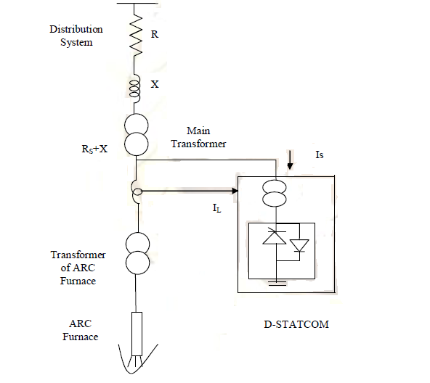
Fig.1.2 Schematic diagram of a STATCOM

1.1.1. Voltage Source Converter (VSI)
A voltage-source converter is a power electronic device that connected in shunt or parallel to the system. It can generate a sinusoidal voltage with any required magnitude, frequency and phase angle. The VSI used to either completely replace the voltage or to inject the missing voltage. The missing voltage is the difference between the nominal voltage and the actual. It also converts the DC voltage across storage devices into a set of three phase AC output voltages. In addition, STATCOM is also capable to generate or absorbs reactive power. If the output voltage of the VSI is greater than AC bus terminal voltages, STATCOM is said to be in capacitive mode. So, it will compensate the reactive power through AC system and regulates missing voltages. These voltages are in phase and coupled with the AC system through the reactance of coupling transformers. Suitable adjustment of the phase and magnitude of the STATCOM output voltages allows effectives control of active and reactive power exchanges between STATCOM and AC system. In addition, the converter is normally based on some kind of energy storage, which will supply the converter with a DC voltage.

Fig: 1.3 Modeling of Inverter

1.2 DESIGN OF CAPACITOR
The charging of the capacitor is referred is to the reactive power in the system. The capacitor charged when the current in the system is higher than in the STATCOM and is discharged when the current is lower. For inverter the most important part is the sequences of operation of the IGBTs. The difference in current between the current before and after the fault is considered as current faults. A suitable range of DC capacitor is needed to store the energy to mitigate the voltage sag. The DC capacitor, CDC is used to inject reactive power to the STATCOM when the voltage is in sag condition.
1.3 BASICS OF THE HARMONICS PHENOMENA:
Harmonics are current and voltages with frequencies that are integer multiples of the fundamental power frequency. For e.g. if the fundamental frequency is 50 Hz. then the 2nd order harmonics is 100Hz, 3rd order is 150Hz. the amplitude and phase angle of the individual component will vary depending on the nature of distorted waveform.
All power electronic converters used in different types of electronic systems can increase harmonic disturbances by injecting harmonic currents directly into the grid. The figure 1.4 below shows how the current harmonics (ih) in the input current (is) of a power electronic converter affect the supply voltage.
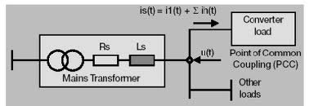
Fig 1.4 Current harmonics in the input current

A harmonic current source feeds current harmonics into the network, which meet harmonic impedances determined by their frequencies. In the harmonic impedances voltage losses are generated. Thus voltage harmonics are generated, which when summing in the direct wave of the voltage, cause distortion, or cracking, of the voltage curve form.
Harmonics are divided into positive, negative and zero sequence components by their properties (ranking numbers). In addition they are divided into even and odd harmonics. In a normal situation when the curve form is symmetric in proportion to origin only odd harmonics are generated. A large number of even harmonics is often a sign of fault or some other unusual situation operation.
In a theoretical case where output current can be estimated as clean DC current, the harmonic current frequencies of a 6-pulse three phase rectifier are n times the fundamental frequency (50 or 60 Hz). The information given below is valid in the case when the line inductance is insignificant compared to the DC reactor inductance. The line current is then rectangular with 120° blocks. The order numbers n are calculated from the formula below:
n = 6K ± 1 where K=1, 2, 3 …
The summation of total harmonics in a system is known as total harmonic distortion (THD). THD+N mean total harmonic distortion plus noise. This measurement is much more common and more comparable between devices. It is usually measured by inputting a sine wave, notch filtering the output, and comparing the ratio between the output signal with and without the sine wave
Mathematically, % THD is given by:
%THD=$\frac{Sum of squares of amplitudes of harmonics}{ Square of amplitude of fundamental}$×100
1.4 SOURCES OF HARMONICS
Harmonics are created by non- linear loads that draw current in abrupt pulses rather than in smooth sinusoidal manner. These pulses cause harmonic currents to flow back into other parts of the power system. Also the power line itself can be an indirect source of voltage harmonics. Examples of non-linear loads are battery chargers, electronic ballasts, variable frequency drives and switching mode power supply. As non-linear current flow through electrical systems and distributions- transmission lines, additional voltage distortions are produced due to impedance associated with electrical network. Thus an electrical power is generated, distributed, and utilized, voltage and current waveform distortions are produced. In a power network the sources of harmonics are:
1.4.1. Ideal Rectifiers:
Static power converters, which convert power from one frequency to another, different rectifier drives in industry, power transmission realized with solid – state technology, generate harmonics. Household electronics are also a source of harmonics e.g. television sets, radio, computers, battery chargers, electronic dimmers etc
1.4.2. Thyristor switches:
In industry, thyristor switches are often used to control the resistive loads, e.g. infra-red dryers. The most common ways of control are the zero point and the phase angle control. In a thyristor controlled drive two thyristor are usually connected in the phase opposite to each other. Thus both negative and positive half cycles can be controlled. Both these methods generate harmonics in the power network.
1.4.3. Arc furnaces:
There are three kinds of melting furnaces in use in industry: resistance, inductance and arc furnaces. Electrically arc furnaces are very problematic loads. Among other things, the asymmetry of load between the phases causes disturbances. The active and the reactive powers taken by the furnaces vary within the frequency of a few hertz, which cause voltage oscillation. An arc furnace also generates harmonics. The current may change so quickly that when examining the curve of current it may be difficult to find two similar consecutive periods. In addition to harmonics the arc furnace produces also inharmonic harmonics and current of frequency below 50Hz. 1.4.4. Transformers:
The magnetic non-linearity of iron is the basic reason of transformer’s harmonic generating effect. Due to the hysteresis of the transformer’s iron core the magnetic flux does not follow the curve form of supply voltage. Magnetization current contains only odd harmonics. Increasing the supply voltage above the nominal value increase harmonics considerably. Also even a low direct current in the secondary saturates the transformer’s core also generates even harmonics in the transformer.
1.5. EFFECTS OF HARMONICS CURRENTS:
The effects of harmonics can be overheating of transformers, cables, motors, generators and capacitors connected to the same power supply with the devices generating the harmonics. Electronic displays and lighting may flicker, circuit breakers can trip, computers may fail and metering can give false readings. If the cause of the above mentioned symptoms is not known, then there is cause to investigate the harmonic distortion of the electricity distribution at the plant. The effects are likely to show up in the customer's plant before they show on the utility system. This Technical Guide has been published to help customers to understand the possible harmonic problems and make sure the harmonic distortion levels are not excessive.
1.5.1. Resonance:
The most harmful phenomenon connected to harmonics is, however, resonance. Resonance is generated, when the frequency of some harmonics is close to the resonance frequency of the network. Resonance is generated between capacitances and inductances of a certain part of the network.
1.5.2. Rectifiers and condensers:
The capacitor banks installed for power factor correction will get over heated due to voltage harmonics in the system. The impedance of the capacitor bank decreases as the frequency of the applied voltage increases and current will increase which will cause overheating and blowing of fuses damaging of the capacitor banks.
The extra stress is caused on the elements of the rectifier bridge and the efficiency decreases.
1.5.3. Transformers and motors:
The flow of harmonic current in the network system increases the distributed network I^2 R losses and increases the voltage drop at farthest end by increasing distribution circuit impedance. With the increased frequency of harmonics voltage will increase the eddy current and hysteresis loss in the transformer/ motor core. Due to increased RMS current, the winding losses also increase.
Harmonic current in motors will cause additional rotating magnetic fields, which rotate in the same direction as fundamental frequency or in the opposite direction. The magnetic field created by the 5th harmonic will try to run the motor in the backward direction.
1.5.4. Telecommunication system:
These systems are also disturbed by the harmonics at speech and radio frequencies.
1.6. EVALUATING HARMONICS:
The "Guide for Applying Harmonic Limits on Power Systems" P519A/D6 Jan 1999 introduces some general rules for evaluating harmonic limits at an industrial facility.
Other methods:
- Load inventory: If you have a lot of equipments such as P.C., printers, motors, solid state heater etc. then there is a good chance that harmonics are present.
- Transformer heat check: If harmonics are present, the transformer can overheat even if the kVA delivered is less than the nameplate rating.
1.7. CONTROL OF HARMONICS:
The methods used in the reduction of harmonics disadvantages are chosen on the basis of technical and economical facts.
1.7.1. Harmonic filters:
Harmonic filters can be divided into two groups: passive filters and active filters.
Passive filters are generally called absorbing circuits. They are series- resonant circuits that form a low-impedance closing way for a harmonic circuit of certain frequency. Filtering can be either concentrated or decentralized. With basic frequency the impedance must be the highest possible to minimize reactive power losses. The absorbing circuits capacitive at its basic frequency. This means it produces inductive reactive power and thus functions as a compensation capacitor at the same time.
An active filter is a type of analog electronic filter that uses active components such as an amplifier. Amplifiers included in a filter design can be used to improve the performance and predictability of a filter. An amplifier prevents the load impedance of the following stage from affecting the characteristics of the filter. An active filter can have complex poles and zeros without using bulky or expensive inductor. Using active elements has some limitations. Available active devices have limited bandwidth, so they are often impractical at high frequencies.
1.7.1.1 First order filter:
The simplest filter is an absorbing circuit tuned to one frequency. The resonance frequency (fr) is ideally dimensioned as close to the frequency of the filterable harmonic as possible. The capacitance of the condenser is generally defined by the needed compensation power of basic frequency. By connecting many filters parallel, all disturbing harmonics can be filtered. This type of solution is usually too expensive.
1.7.1.2 Second order filter:
A double tuned filter can be used to filter two different harmonics at the same time. The losses of the basic frequency are smaller than when using two separate filters. If there are many harmonics to be filtered, the most economic solution is to tune a separate filter for each small frequency (250- 550Hz) and a broadband filter for high frequency harmonics.
1.7.2. Over sizing or derating of the installation
This solution does not attempt to eliminate the harmonic currents flowing in the low voltage (less than 1,000VAC) electrical distribution system but rather to "mask" the problem and avoid the consequences.
When designing a new installation, the plan is to oversize all elements likely to transmit harmonic currents, namely the transformers, cables, circuit breakers, engine generator sets and the distribution switchboards. The most widely implemented solution is over sizing of the neutral conductor.
In existing installation, the most common solution is to derate the electrical distribution equipment subjected to the harmonic currents. The consequence is an installation that cannot be used to its full potential.
Conclusion: The result is a major increase in the cost of electrical distribution system. 1.7.3. Specially Connected Transformers:
This solution inhibits propagation of third-order harmonic currents and their multiples. It is a centralized solution for a set of single-phase loads. However, it produces no effect on other harmonic orders that are not multiples of three (H5, H7, etc). On the contrary, this solution limits the available power from the source and increases the line impedance.
Conclusion: The consequence is an increase in the voltage distortion due to the other harmonic orders
1.7.4. Series Reactors:
This solution, used for variable speed drives and three phase rectifiers, consists in connecting a reactor in series upstream of a non-linear load. A reactor is not expensive, but has limited effectiveness. One must be installed for each non-linear load. Current distortion is divided by a factor of approximately two.
Conclusion: Harmonic current still greater than IEEE 519-1992
1.7.5. Structural Modification:
The structural modifications can be to strengthen the supply, to use 12 or more pulse drive, to use a controlled rectifier or to improve the internal filtering in the drive.
1.8. SOURCES OF ENERGY
Energy sources are of mainly two type’s renewable and nonrenewable energy sources. Among them renewable energy is the energy from the natural sources such as sunlight, wind, rain, tides, waves and geothermal heat. The reported problem with these renewable resources is it is difficult and expensive to harness enough power from them to match the effectives of nonrenewable energy resources. Among the all the energy sources in this project we are using the wind energy as the source.
1.8.1 WIND POWER
Wind is a movement of air on the surface of earth. Sunbeams heat the earth irregular, what create atmospheric pressure differences, between which the air moves and makes the wind. Irregular heating is due to angle of sunbeam radiation, type of heating surface (water, soil, rocks, and sands), level of clouded, terrain configuration, elevation, and day cycle. However the Sun is not only one reason of wind. There are also the Orioles forces, in global meaning and many local factors such as e.g. mountainous terrain surface or forest areas.
Advantages
• Continuous sources of energy
• Clean source of energy
• No emissions into the atmosphere
• Does not add to thermal burden of the earth
• Produces no health-damaging air pollution or acid rain
Disadvantages
• For most locations, wind power density is low
• Wind velocity must be greater than 7 mph to be usable in most areas
• Problem exists in variation of power density and duration (not reliable)
• Need better ways to store energy

2. LITERATURE SURVEY

2.1. POWER QUALITY
Our technological world has become deeply dependent upon the continuous availability of electrical power. In most countries commercial power is made available via nationwide grids, interconnecting numerous generating stations to the loads. The grid must supply basic national needs of residential, lighting, heating, refrigeration, air conditioning and transportation as well as critical supply to governmental, industrial, financial, commercial, and medical and communications communities. Commercial power literally enables today’s modern world to function at its busy pace.
Many power problems originate in the commercial power grid, which with its thousands of miles of transmission lines is subject to weather conditions such as hurricanes, lightning storms, snow, ice and flooding along with equipment failure, traffic accidents and major switching operations. Also power problems affecting today’s technological equipment are often generated locally within a facility from any number of situations such as local construction, heavy startup loads, faulty distribution components and even typical background electrical noise.
Widespread use of electronics in everything from home electronics to the control of massive and costly industrial processes has raised the awareness of power quality. Power quality or more specifically a power quality disturbance is generally defined as any change in power (voltage, current or frequency) that interferes with the normal operation of electrical equipment.
The study of power quality and ways to control it is a concern for electric utilities, large industrial companies, businesses and even home users. The study has intensified as equipment has become increasingly sensitive to even minute changes in the power supply voltage, current, and frequency.
Definition:
“Power Quality is the degree to which both the utilization and delivery of electric power affects the performance of electric equipment”.
In general there is no unique definition of power quality. The power quality problem can be viewed from two different angles related to each side of the utility meter, namely the Utility and Consumer. An alternative definition of PQ is adopted.
A perfect power supply would be one that is always available always within voltage and frequency tolerances and has a pure noise-free sinusoidal wave shape. Power Quality means the ability of utilities to provide electric power without interruption.
2.1.1. Power Quality Disturbances:
Major Causes: Faults, Starting of large loads, and Brown-out recovery.
Major Consequences: Shorts, Accelerated aging, loss of data or stability, Process interrupts, etc.
A. Capacitor Switching Transients:
Major Causes: A Power factor correction method.
Major Consequences: Insulation breakdown or spark over, semi conductor device damage, shorts, accelerated aging, loss of data or stability.
B. Harmonics:
Major Causes: Power electronic equipment, arcing, transformer saturation.
Major Consequences: Equipment over heating, high voltage/current, protective device operations.
C. Lightning Transients:
Major Causes: Lightning strikes.
Major Consequences: Insulation breakdown or spark over, semi conductor device damage, shorts, accelerated aging, loss of data or stability.
D. High Impudence Faults:
Major Causes: Fallen conductors, trees (fail to establish a permanent return path)
Major Consequences: Fire, threats to personal safety.
Mainly the seven types of Power Quality problems are there. They are
1. Transients.
2. Interruptions.
3. Voltage Sag.
4. Voltage Swell.
5. Waveform distortion.
6. Voltage fluctuations.
7. Frequency variations.
2.1.2. Transients
Potentially the most damaging type of power disturbance transients fall into two subcategories:
1. Impulsive.
2. Oscillatory.
2.1.3. Impulsive
Impulsive transients are sudden high peak events that raise the voltage and/or current levels in either a positive or a negative direction. These types of events can be categorized further by the speed at which they occur (fast, medium and slow). Impulsive transients can be very fast events (5 nanoseconds [ns] rise time from steady state to the peak of the impulse) of short-term duration (less than 50 ns).
Note: [1000 ns = 1 µs], [1000 µs = 1 ms], [1000 ms = 1 second]
One example of a positive impulsive transient caused by electrostatic discharge (ESD) event is illustrated in Figure 2.1
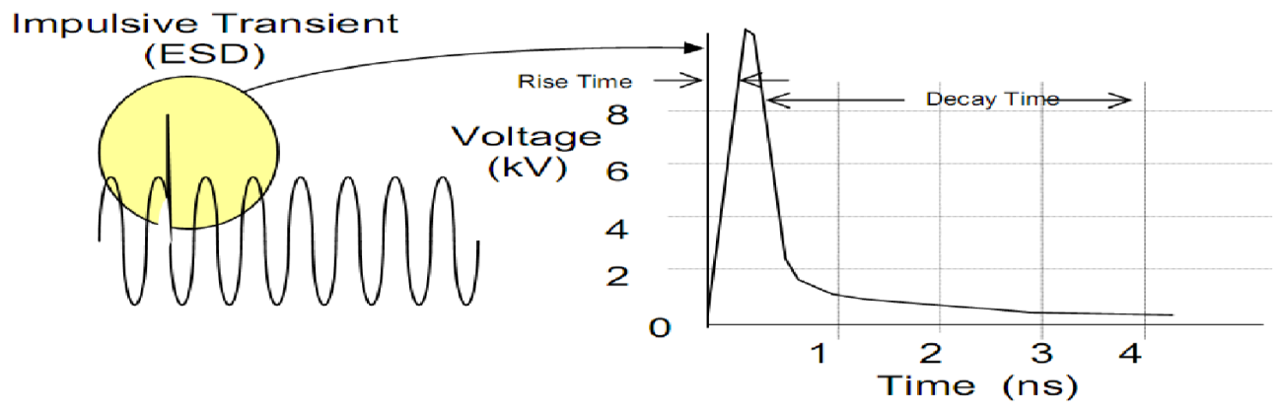
Fig 2.1: Positive Impulsive Transient

Causes of impulsive transients include lightning, poor grounding, the switching of inductive loads, utility fault clearing and ESD (Electrostatic Discharge). The results can range from the loss (or corruption) of data to physical damage of equipment. Of these causes, lightning is probably the most damaging.
2.1.4. Oscillatory
An oscillatory transient is a sudden change in the steady-state condition of a signal's voltage, current or both at the positive and negative signal limits oscillating at the natural system frequency. In simple terms the transient causes the power signal to alternately swell and then shrink very rapidly. Oscillatory transients usually decay to zero within a cycle (a decaying oscillation).
These transients occur when you turn off an inductive or capacitive load such as a motor or capacitor bank. An oscillatory transient results because the load resists the change. This is similar to what happens when you suddenly turn off a rapidly flowing faucet and hear a hammering noise in the pipes. The flowing water resists the change and the fluid equivalent of an oscillatory transient occurs.
For example upon turning off a spinning motor it acts briefly as a generator as it powers down, thereby producing electricity and sending it through the electrical distribution. A long electrical distribution system can act like an oscillator when power is switched on or off, because all circuits have some inherent inductance and distributed capacitance that briefly energizes in a decaying form.
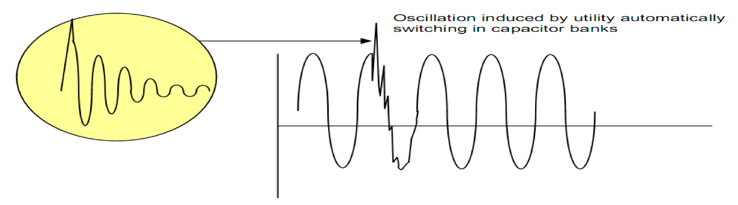Fig 2.2: Oscillatory Transient

When oscillatory transients appear on an energized circuit, usually because of utility switching operations (especially when capacitor banks are automatically switched into the system), they can be quite disruptive to electronic equipment. Figure2.2 shows a typical low frequency Oscillatory Transient attributable to capacitor banks being energized.
2.1.5. Interruptions
An interruption (Fig2.3) is defined as the complete loss of supply voltage or load current. Depending on its duration, an interruption is categorized as instantaneous, momentary, temporary or sustained. Duration range for interruption types are as follows:
Instantaneous - 0.5 to 30 cycles
Momentary - 30 cycles to 2 seconds
Temporary - 2 seconds to 2 minutes
Sustained - greater than 2 minutes
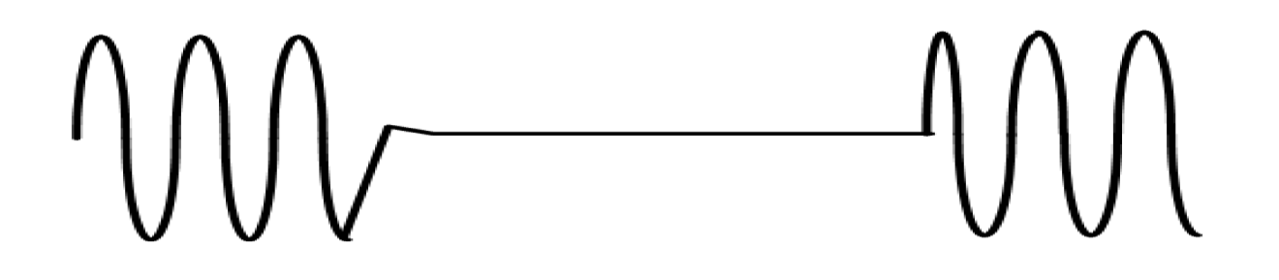
Fig 2.3: Momentary Interruption

The causes of interruptions can vary, but are usually the result of some type of electrical supply grid damage such as lightning strikes, animals, trees, vehicle accidents, destructive weather (high winds, heavy snow or ice on lines, etc.), equipment failure or a basic circuit breaker tripping. While the utility infrastructure is designed to automatically compensate for many of these problems, it is not infallible. One of the more common examples of what can cause an interruption in commercial power systems are utility protective devices such as automatic circuit reclosers.
Reclosers determine the length of time of most interruptions depending on the nature of the fault. Reclosers are devices used by utility companies to sense the rise in current from a short circuit in the utility infrastructure and to shut off the supply power when this occurs. The recloser will after a set time bring power back on line, in an attempt to burn off the material creating the short circuit (This material is often a tree limb or small animal trapped between the line and ground).
An interruption whether it is instantaneous, momentary, temporary or sustained can cause disruption, damage and downtime, from the home user up to the industrial user. A home or small business computer user could lose valuable data when information is corrupted from loss of power to their equipment.
2.1.6. Voltage Sag
Sag (Fig 2.4) is a reduction of AC voltage at a given frequency for the duration of 0.5 cycles to 1 minute’s time. Sags are usually caused by system faults and are also often the result of switching on loads with heavy startup currents.

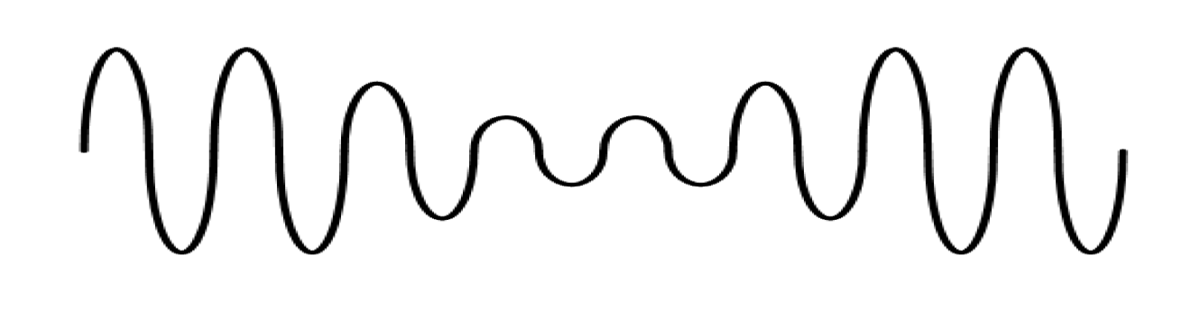
Fig 2.4: Voltage Sag

Common causes of sags include starting large loads (such as one might see when they first start up a large air conditioning unit) and remote fault clearing performed by utility equipment. Similarly, the starting of large motors inside an industrial facility can result in significant voltage drop (sag). A motor can draw six times its normal running current or more, while starting. Creating a large and sudden electrical load such as this will likely cause a significant voltage drop to the rest of the circuit it resides on. If you could imagine someone turning on all the water in your house while you’re in the shower. The water would probably run cold and the water pressure would drop. Of course, to solve this problem you might have a second water heater that is dedicated to the shower. The same holds true for circuits with large startup loads that create a large inrush current draw.
While it may be the most effective solution adding a dedicated circuit for large startup loads may not always be practical or economical, especially if a whole facility has a myriad of large startup loads. Other solutions to large starting loads include alternative power starting sources that do not load the rest of the electrical infrastructure at motor startup such as, reduced-voltage starters, with either autotransformers or star-delta configurations. A solid-state type of soft starter is also available and is effective at reducing the voltage sag at motor start-up. Most recently, adjustable speed drives (ASDs), which vary the speed of a motor in accordance with the load (along with other uses), have been used to control the industrial process more efficiently and economically and as an additional benefit, addresses the problem of large motor starting.
As mentioned in the Interruptions section, the attempt of the utility infrastructure to clear remote faults can cause problems for end users. When this problem is more evident it is seen as an interruption. However, it can also manifest itself as sag for problems that are cleared more quickly or that are momentarily recurring. Some of the same techniques that were used to address interruptions can be utilized to address voltage sags: UPS equipment, motor generators, and system design techniques. However, sometimes the damage being caused by sags is not apparent until the results are seen over time (damaged equipment, data corruption, errors in industrial processing).
2.1.7. Voltage Swell
A swell (Figure2.5) is the reverse form of sag, having an increase in AC voltage for duration of 0.5 cycles to 1 minute’s time. For swells, high-impedance neutral connections, sudden (especially large) load reductions and a single-phase fault on a three-phase system are common sources.
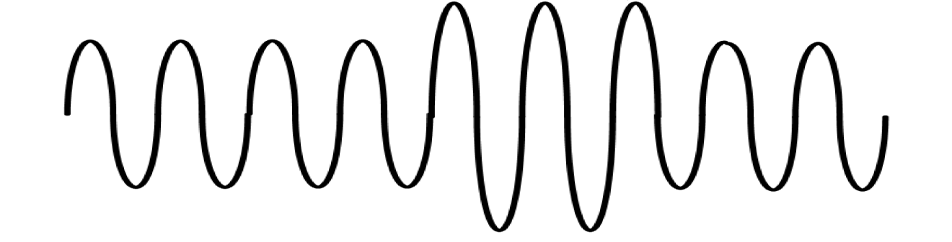Fig2.5: Voltage Swell

The result can be data errors, flickering of lights, degradation of electrical contacts, semiconductor damage in electronics and insulation degradation. Power line conditioners, UPS systems and ferroresonant control transformers are common solutions. Much like sags, swells may not be apparent until their results are seen. Having UPS and/or power conditioning devices that also monitor and log incoming power events will help to measure when and how often these events occur.
2.1.8. Waveform Distortion
There are five primary types of waveform distortion:
1. DC offset
2. Harmonics
3. Inter harmonics
4. Notching
5. Noise
2.1.9. DC Offset
Direct current (DC) can be induced into an ac distribution system, often due to failure of rectifiers within the many AC to DC conversion technologies that have proliferated modern equipment. DC can traverse the AC power system and add unwanted current to devices already operating at their rated level. Overheating and saturation of transformers can be the result of circulating DC currents. When a transformer saturates, it not only gets hot, but also is unable to deliver full power to the load, and the subsequent waveform distortion can create further instability in electronic load equipment. A DC offset is illustrated in Fig 2.6.
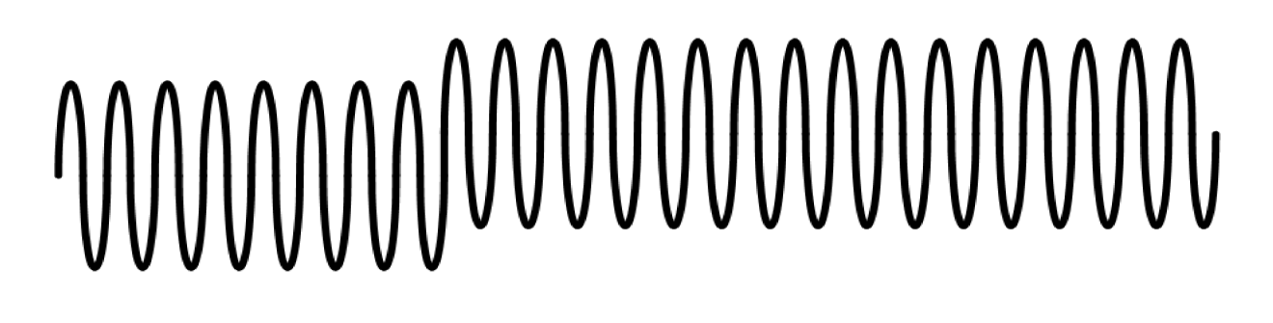
Fig 2.6: DC Offset

The solution to DC offset problems is to replace the faulty equipment that is the source of the problem. Having very modular, user replaceable, equipment can greatly increase the ease to resolve DC offset problems caused by faulty equipment, with less costs than may usually be needed for specialized repair labor.
2.1.10. Harmonics
Harmonic distortion is the corruption of the fundamental sine wave at frequencies that are multiples of the fundamental. (e.g., 180Hz is the third harmonic of a 60Hz fundamental frequency 3 X 60 = 180).
Symptoms of harmonic problems include overheated transformers, neutral conductors and other electrical distribution equipment, as well as the tripping of circuit breakers and loss of synchronization on timing circuits that are dependent upon a clean sine wave trigger at the zero crossover point.
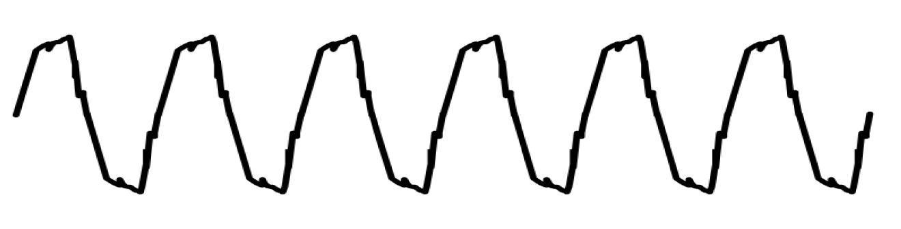
Fig 2.7: Typical Harmonic Waveform Distortion

Harmonic distortion has been a significant problem with IT equipment in the past, due to the nature of switch-mode power supplies (SMPS). These non-linear loads and many other capacitive designs, instead of drawing current over each full half cycle, “sip” power at each positive and negative peak of the voltage wave. The return current, because it is only short-term, (approximately 1/3 of a cycle) combines on the neutral with all other returns from SMPS using each of the three phases in the typical distribution system. Instead of subtracting, the pulsed neutral currents add together, creating very high neutral currents, at a theoretical maximum of 1.73 times the maximum phase current. An overloaded neutral can lead to extremely high voltages on the legs of the distribution power, leading to heavy damage to attached equipment. At the same time, the load for these multiple SMPS is drawn at the very peaks of each voltage half-cycle, which has often led to transformer saturation and consequent overheating. Other loads contributing to this problem are variable speed motor drives, lighting ballasts and large legacy UPS systems. Methods used to mitigate this problem have included over-sizing the neutral conductors, installing K-rated transformers and harmonic filters.
2.1.11. Harmonics Mitigation Techniques
The generation of harmonics, whenever an adjustable speed drive is used, is inevitable. The order and magnitude of these harmonics will greatly depend on the drive configuration and system impedance. The various harmonic mitigation techniques available are as follows:
A. Phase Multiplication:
Whether the drive is AC or DC, the common means of reducing harmonics generation while in the design process is by phase multiplication or harmonic cancellation. It is effective in reducing low order harmonics as long as the load is balanced.
B. Passive filters:
Improved power factor reduces high frequency harmonics. Large tuning reactors are not used as instability may occur due to parallel resonance with the source impedance. Performance depends upon source impedance. It cannot be measured accurately and can vary with system changes. Hence, passive filters are not appropriate for cycloconverters.
C. Active filters:
With improved power factor, the output current can be controlled. Active filters provide stable operation against AC source impedance variation, and fast responsive irrespective of the order and magnitude of harmonics. These filters are appropriate for cycloconverters. The initial and running costs are usually higher than passive filters. The injection may flow into other components.
D. Harmonic injection:
Harmonic injection takes care of uncharacteristic harmonics. System impedance is not a part of the design criteria as it may give rise to low order harmonics
F. Harmonic mitigation techniques with PWM:
Harmonics can be reduced to less than one per cent of the fundamental with the help of PWM; it is programmable to eliminate specific harmonics. In addition to the above techniques, harmonics can be reduced by a number of circuit techniques.
2.1.12. Inter Harmonics
Inter harmonics (Fig:2.8) are a type of waveform distortion that are usually the result of a signal imposed on the supply voltage by electrical equipment such as static frequency converters, induction motors and arcing devices. Cycloconverters (which control large linear motors used in rolling mill, cement and mining equipment), create some of the most significant inter harmonic supply power problems. These devices transform the supply voltage into an AC voltage of a frequency lower or higher than that of the supply frequency. The most noticeable effect of inter harmonics is visual flickering of displays and incandescent lights, as well as causing possible heat and communication interference.
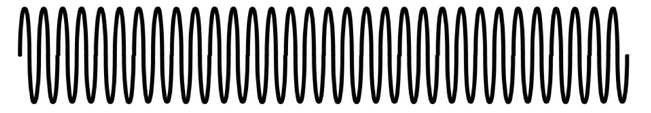
Fig 2.8: Inter Harmonic Waveform Distortion

Solutions to inter harmonics include filters, UPS systems, and line conditioners.
2.1.13. Notching
Notching (Fig 2.9) is a periodic voltage disturbance caused by electronic devices, such as variable speed drives, light dimmers and arc welders under normal operation. This problem could be described as a transient impulse problem, but because the notches are periodic over each ½ cycle notching is considered a waveform distortion problem. The usual consequences of notching are system halts, data loss and data transmission problems.
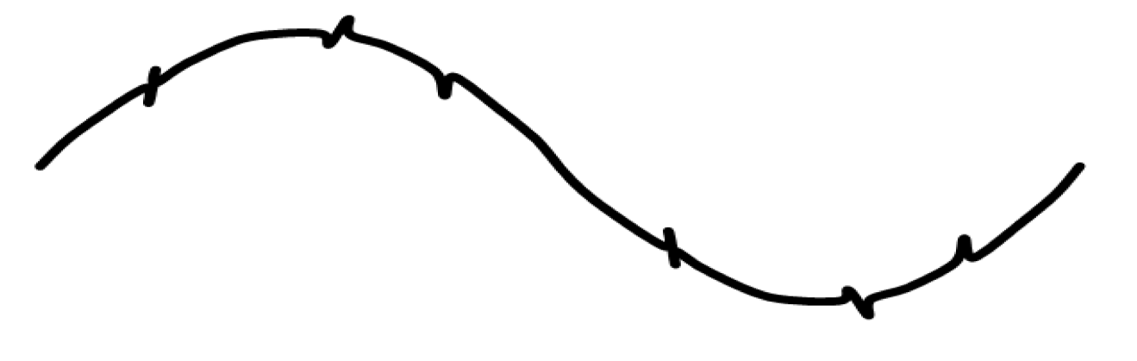
Fig.2.9. Notching

One solution to notching is to move the load away from the equipment causing the problem (if possible). UPSs and filter equipment are also viable solutions to notching if equipment cannot be relocated.
2.1.14. Noise
Noise (Fig 2.10) is unwanted voltage or current superimposed on the power system voltage or current waveform. Noise can be generated by power electronic devices, control circuits, arc welders, switching power supplies, radio transmitters and so on. Poorly grounded sites make the system more susceptible to noise. Noise can cause technical equipment problems such as data errors, equipment malfunction, long-term component failure, hard disk failure and distorted video displays.
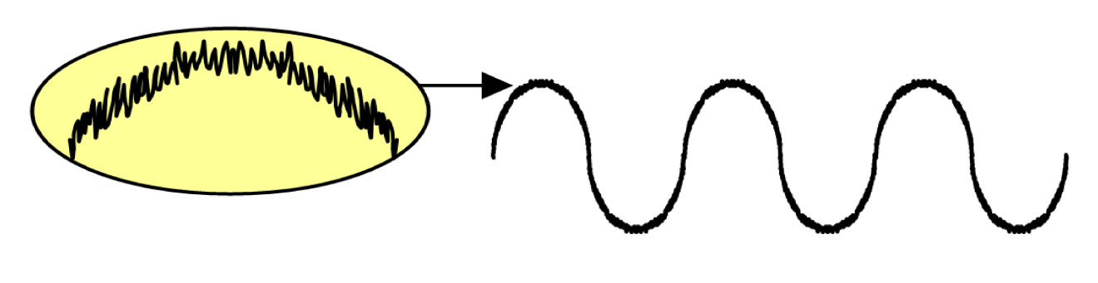
Fig 2.10: Noise

There are many different approaches to controlling noise and sometimes it is necessary to use several different techniques together to achieve the required result. Some methods are:
• Isolate the load via a UPS
• Install a grounded, shielded isolation transformer
• Relocate the load away from the interference source
• Install noise filters
• Cable shielding
2.1.15. Voltage Fluctuations
Since voltage fluctuations are fundamentally different from the rest of the waveform anomalies, they are placed in their own category. A voltage fluctuation (Fig 2.11) is a systematic variation of the voltage waveform or a series of random voltage changes of small dimensions namely 95 to 105% of nominal at a low frequency generally below 25 Hz.
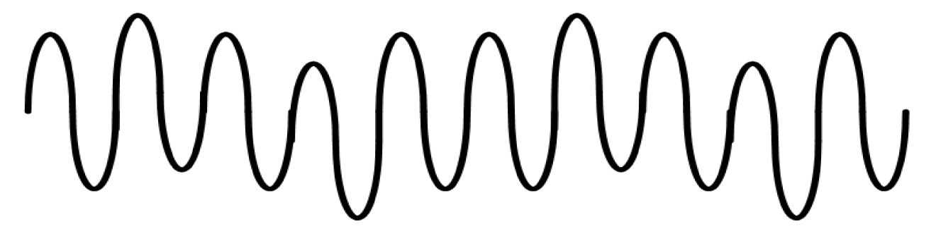
Fig 2.11: Voltage Fluctuations

Any load exhibiting significant current variations can cause voltage fluctuations. Arc furnaces are the most common cause of voltage fluctuation on the transmission and distribution system. One symptom of this problem is flickering of incandescent lamps. Removing the offending load, relocating the sensitive equipment or installing power line conditioning or UPS devices are methods to resolve this problem.
2.1.16. Frequency Variations
Frequency variation (Fig 2.12) is extremely rare in stable utility power systems, especially systems interconnected via a power grid. Where sites have dedicated standby generators or poor power infrastructure, frequency variation is more common especially if the generator is heavily loaded. IT equipment is frequency tolerant and generally not affected by minor shifts in local generator frequency. What would be affected would be any motor device or sensitive device that relies on steady regular cycling of power over time. Frequency variations may cause a motor to run faster or slower to match the frequency of the input power. This would cause the motor to run inefficiently and/or lead to added heat and degradation of the motor through increased motor speed and/or additional current draw.
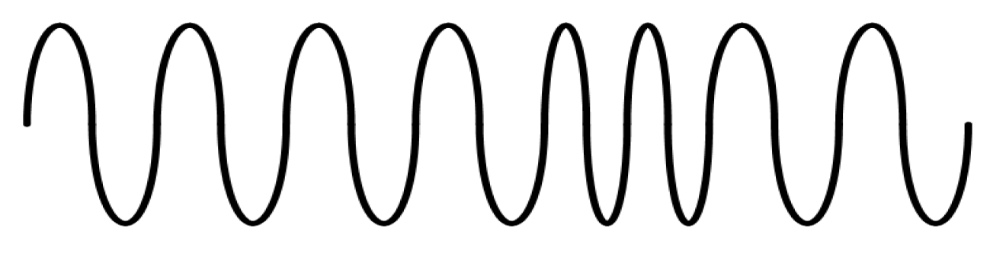
Fig 2.12: Frequency Variations

To correct this problem all generated power sources and other power sources causing the frequency variation should be assessed, then repaired, corrected
2.2. SOLUTIONS TO POWER QUALITY PROBLEMS
There are two approaches to the mitigation of power quality problems. The solution to the power quality can be done from customer side or from utility side. First approach is called load conditioning, which ensures that the equipment is less sensitive to power disturbances, allowing the operation even under significant voltage distortion. The other solution is to install line conditioning systems that suppress or counteracts the power system disturbances. A flexible and versatile solution to voltage quality problems is offered by active power filters. Currently they are based on PWM converters and connect to low and medium voltage distribution system in shunt or in series. Series active power filters must operate in conjunction with shunt passive filters in order to compensate load current harmonics. Shunt active power filters operate as a controllable current source and series active power filters operates as a controllable voltage source. Both schemes are implemented preferable with voltage source PWM inverters, with a dc bus having a reactive element such as a capacitor. Active power filters can perform one or more of the functions required to compensate power systems and improving power quality. Their performance also depends on the power rating and the speed of response.
Solutions will play a major role in improving the inherent supply quality; some of the effective and economic measures can be identified as following:
2.2.1. Lightening and Surge Arresters:
Arresters are designed for lightening protection of transformers, but are not sufficiently voltage limiting for protecting sensitive electronic control circuits from voltage surges.
2.2.2. Thyristor Based Static Switches:
The static switch is a versatile device for switching a new element into the circuit when the voltage support is needed. It has a dynamic response time of about one cycle. To correct quickly for voltage spikes, sags or interruptions, the static switch can used to switch one or more of devices such as capacitor, filter, alternate power line, energy storage systems etc. The static switch can be used in the alternate power line applications. This scheme requires two independent power lines from the utility or could be from utility and localized power generation like those in case of distributed generating systems. Such a scheme can protect up to about 85 % of interruptions and voltage sags.
2.2.3. Energy Storage Systems:
Storage systems can be used to protect sensitive production equipments from shutdowns caused by voltage sags or momentary interruptions. These are usually DC storage systems such as UPS, batteries, superconducting magnet energy storage (SMES), storage capacitors or even fly wheels driving DC generators. The output of these devices can be supplied to the system through an inverter on a momentary basis by a fast acting electronic switch. Enough energy is fed to the system to compensate for the energy that would be lost by the voltage sag or interruption. In case of utility supply backed by a localized generation this can be even better accomplished.
2.2.4. Electronic tap changing transformer:
A voltage-regulating transformer with an electronic load tap changer can be used with a single line from the utility. It can regulate the voltage drops up to 50% and requires a stiff system (short circuit power to load ratio of 10:1 or better). It can have the provision of coarse or smooth steps intended for occasional voltage variations.

2.2.5. Harmonic Filters:
Filters are used in some instances to effectively reduce or eliminate certain harmonics. If possible, it is always preferable to use a 12-pluse or higher transformer connection, rather than a filter. Tuned harmonic filters should be used with caution and avoided when possible. Usually, multiple filters are needed, each tuned to a separate harmonic. Each filter causes a parallel resonance as well as a series resonance, and each filter slightly changes the resonances of other filters.
2.2.6. Constant-Voltage Transformers:
For many power quality studies, it is possible to greatly improve the sag and momentary interruption tolerance of a facility by protecting control circuits. Constant voltage transformer (CVTs) can be used on control circuits to provide constant voltage with three cycle ride through, or relays and ac contactors can be provided with electronic coil hold-in devices to prevent mis-operation from either low or interrupted voltage.
2.2.7. Digital-Electronic and Intelligent Controllers for Load-Frequency Control:
Frequency of the supply power is one of the major determinants of power quality, which affects the equipment performance very drastically. Even the major system components such as Turbine life and interconnected-grid control are directly affected by power frequency. Load frequency controller used specifically for governing power frequency under varying loads must be fast enough to make adjustments against any deviation. In countries like India and other countries of developing world, still use the controllers which are based either or mechanical or electrical devices with inherent dead time and delays and at times also suffer
2.3 POWER QUALITY APPLICATIONS:
Shunt capacitors have several uses in the electric power systems. They are utilized as sources of reactive power by connecting them in line -to- neutral. Electric utilities have also connected capacitors in series with long lines in order to reduce its impudence. This is particularly common in the transmission level, where the lines have length in several kilometres.
Shunt capacitors are usually called “power factor correction capacitors”, although they serve other functions and provide multiple benefits. They are used at all voltage levels from end-user utilization to extra high voltages.
Shunt capacitors are at customer location for power factor correction or on the distribution system for voltage control from ageing and associated effects. In future perspective, such cont rollers can be replaced by their Digital -electronic counterpart.
2.4. USE OF CUSTOM POWER DEVICES TO IMPROVE POWER QUALITY
In order to overcome the problems such as the ones mentioned above, the concept of custom power devices is introduced recently; custom power is a strategy, which is designed primarily to meet the requirements of industrial and commercial customer. The concept of custom power is to use power electronic or static controllers in the medium voltage distribution system aiming to supply reliable and high quality power to sensitive users. Power electronic valves are the basis of those custom power devices such as the static transfer switch, active filters and converter-based devices. Converter based power electronics devices can be divided in to two groups: shunt-connected and series-connected devices. The shunt connected devices is known as the DSTATCOM and the series device is known as the Static Series Compensator (SSC), commercially known as DVR. It has also been reported in literature that both the SSC and DSTATCOM have been used to mitigate the majority the power system disturbances such as voltage dips, sags, flicker unbalance and harmonics.
For lower voltage sags, the load voltage magnitude can be corrected by injecting only reactive power into the system. However, for higher voltage sags, injection of active power, in addition to reactive power, is essential to correct the voltage magnitude. Both DVR and DSTATCOM are capable of generating or absorbing reactive power but the active power injection of the device must be provided by an external energy source or energy storage system. The response time of both DVR and DSTATCOM is very short and is limited by the power electronics devices. The expected response time is about 25 ms, and which is much less than some of the traditional methods of voltage correction such as tap – changing transformers.
2.5 RENEWABLE ENERGY SOURCES:
The Earth has a lot of renewable energy sources such as the Sun, water etc. There is also plenty of energy extracting methods. The thesis describes and compares major technical, economic, environmental, social and public aspects of renewable energy sources and presents collected information and results on the website. It is a part of project, which includes web presentation about some of major categories of present energy industry issues (renewable energy sources – the RES, nuclear energy, carbon capture and storage – the CCS, energy conservation and demand site management).
2.6 OBJECTIVES
The objectives are to compare available for humanity technologies which can be used to extract energy from renewable resources and to present the results as a website. The site allow for getting more familiar with the RES, their history, present situation and potential (mainly in the European Union but also in the other countries of the world).
The thesis shows that the RES are getting common, profitable and competitive relative to present energy sources like coal, gas or nuclear energy. Although technology is used for short time some of them have got mature quickly e.g.: wind turbines, hydro power plants or biomass combustion, there are still sources with large technical potential, such a photovoltaic systems, wave and tidal stream generators. However the grid connection problem is still common for all of them in most of countries. The difference is getting from barriers like financial constraints. In general the technologies are relatively expansive and required more time for researches to get competitive with other energy sources. In many countries there are also large legislation barriers. Technology development is faster and requires less time than introducing changes into law.
Therefore although investors have technologies and know how knowledge they have to wait till legislation barrier will be removed. The most common problem is mentioned grid connection (who is responsible for connection and who pay for it) and land lease. Technical progress is also slowed by environmental and public awareness issues. Society is not enough educated and often people does not allow for the RES in their neighborhood. Some technologies like tidal barrages, biomass power plants or wind parks have also large impact on environment and the ecologist efficiently prevent the construction of new systems
2.7. ORGANIZATION
The thesis described the Renewable Energy Sources in technical, economic, legal, environmental and public aspects. Description of technology is divided on five related with energy source categories: wind power, solar power, wave and tidal power, hydropower, bio power. Each of those chapters consist of short introduction which gives credit about energy source, description of technology which accurately depict principle related with electricity generation. The last parts are about grid connection. Economic aspects chapter depicts about investment and operation costs, devices lifetime and related with investment costs. The next chapter includes information about public awareness problems and environmental impact of each technology. Law review is the last one subchapter of the state of the art. It depict legislation situation of the RES technologies in each Member State of the EU. The final comparison is further part. The chapter compares all of the described technologies in all of the categories. Comparison is included in form of the tables which consists of common relative and absolute factors.
2.8 WIND POWER
Wind is a movement of air on the surface of earth. Sunbeams heat the earth irregular, what create atmospheric pressure differences, between which the air moves and makes the wind. Irregular heating is due to angle of sunbeam radiation, type of heating surface (water, soil, rocks, and sands), level of clouded, terrain configuration, elevation, and day cycle. However the Sun is not only one reason of wind. There are also the Orioles forces, in global meaning and many local factors such as e.g. mountainous terrain surface or forest areas. Below picture depict exemplary temperature levels of air on the earth.
Velocity and Power Relations
Energy of wind is definition as kinetic energy: movement of air mass m, with speed v. Formula below shows that dependence:
E = $\frac{1}{2}$ mv² (2.1)
Related to above, formula of wind stream power looks like below (only for constant wind speed)
P_{wind} = $\frac{dE}{dt}$ =$\frac{1}{2}$m’v² (2.2)
Where
m’ – mass flow per second
If treated m as a mass flow rate of the air per second, it given by the following expression:
P_{wind =} $\frac{1}{2}$ _{ρAv}³ (2.3)
Where:
ρ – Air density
A – Area swept by the rotating blades
v – Wind speed
It easy to see that mechanical power have a cubic relation with wind speed. It is considerable advantage in situation when the wind is blowing with constant speed but this condition is happens rarely in real. Therefore that cubic relation is significant disadvantages of wind turbine making them very floating resource.
2.9. WIND POWER SYSTEM
Even if the wind turbine is operating as a single turbine or as a farm, each turbine is made of the following components: tower structure, propeller (rotor with blades attached to the hub), shaft with mechanical gear, electrical generator, yaw mechanism, sensors and control (with stall controller), anemometers, numerous sensors, power electronic to convert and condition power, control electronics, battery and transmission link. Below is a short description each one of the most important elements including information about main function:
• Tower
This is the biggest part of wind turbine. Tower structure is assembled from tower and nacelle where the yaw mechanism is installed as well as an electrical generator, stall control and all of the mechanical gears. The picture bellow depicts the components of nacelle.

Fig. 2.13 Nacelle details of a wind turbine: a) blade, b) gear box, c) low speed shaft, d) anemometer, e) breaker on the high speed shaft, f) generator, g) transformer, h) control system, i) yaw drive, j) yaw motor

Large tower are build as tubular steel towers, lattice towers, concrete towers or in small turbine case, guyed tubular towers. The height of the tower is in few rotor diameter but not lower than from 25 to 30 meters in order to avoid turbulence caused e.g. by trees, high rocks or buildings. The main problem in the tower design is vibration caused by rotor rotation and wind speed fluctuation. Therefore designers have to design the tower avoiding the resonance frequencies. The cost of the tower is nearly 20 per cent of a total cost of wind turbine.
• Rotor
The most common type of a rotor is a three-blade rotor. The main factor of the rotor is the swept rotor area. The turbine power is in linear relation, correspondingly to equation (2.3), therefore turbines with short blades have lower power that rotor with long blades. In modern turbines with large swept area, blades can also swirl for regulation. A large rotor cost is relatively lower than of a smaller, it has better parameters and covers less area but on the other hand farm assembled from many small rotors has lower the cost of infrastructure, the energy in farm output has less fluctuation, several machines decrease the risk of turn off of a farm in case when one of them temporarily fails and smaller machines can be installed in areas when the grid is too weak to handle too much energy from large turbines.
• Shaft with mechanical gear
The construction of this element is not very complicated. The main part is a gear box. It is a mechanism, which converts slow speed rotation of a wind rotor to high-speed rotation of a generator.
• Electrical generator
In modern wind turbines there are two types of three-phase generators: synchronous and asynchronous generator. But nowadays, the most common is that second one due to the method of rotor feeds. A synchronous machine required DC current to feed rotor, therefore each generator needs their own DC current source or permanent magnet inside a stator. This solution can operate with low speed rotation, thus can operate also without a gearbox and allow full control of active and reactive power.
Fig. 2.14 Electrical scheme of wind power plant with synchronous generator
An asynchronous machine (induction machine) has squirrel cage rotor which does not need to be feed. Other advantages of the induction machine are e.g.: low capital cost, low maintenance and better transient performance.
Fig. 2.15 Electrical scheme of wind power plant with asynchronous generator

Relatively new technology is double fed induction generator. This solution allowed for the transmission energy in two directions, into and from rotor. This feature has a few significant advantages: output power optimization (allows to change rotation speed what increase turbine efficiency related to wind speed changes), to use rotor rotation as energy inventory (overflow is warehouse in kinetic form when wind speed is fall off), fast adjust to wind speed changes (in this case is allowed to fast changes of wind rotor speed and in the same time to use blasts energy), passive energy regulation without using capacitor battery, lower level of loud emission, less exhaustion of gear box, blades and tower, energy quality improvement, active curtail of power and voltage fluctuation also higher current and voltage harmonics.
Fig. 2.16 Electrical scheme of wind power plant with double feed asynchronous generator

• Yaw mechanism
This mechanism allows for conforming wind turbine position to wind flow direction. This mechanism cooperates with anemometers and sensors.
• Sensors and control
This system is responsible for measure important values and control prime parameters of a turbine. Speed control methods fall into few categories: no speed control whatsoever (to control extreme wind speed), yaw and tilt control (to orients the rotor in the direction of the wind), pitch control (to change the pitch of the blade with wind speed changes), stall control (to position rotor and blades in case when turbine does not works). In older versions of wind farms, have central control but in modern turbines, each turbine must have their own control system what is related with lower the moment of inertia than in a farms with central control system.
2.10. MICRO GRID SYSTEM:
In the micro grid system, the distributed energy resource (DER) based single-phase inverter is usually adopted. In order to reduce conversion losses, the key is to save costs and size by removing any kind of transformer as well as reducing the power devices. The objective of this paper is to study a novel five level multi string inverter topology for DERs based DC/AC conversion system. In this study, a high step-up converter is introduced as a front-end stage to improve the conversion efficiency of conventional boost converters and to stabilize the output DC voltage of various DERs such as PV and fuel cell modules for use with the simplified multilevel inverter. The simplified multilevel inverter requires only six active switches instead of the eight required in the conventional cascaded Hbridge (CCHB) multilevel inverter. In addition, two active switches are operated under line frequency. The studied multistring inverter topology offers strong advantages such as improved output waveforms, smaller filter size, and lower EMI and THD. Simulation and experimental results show the effectiveness of the proposed solution.
In light of public concern about global warming and climate change, much effort has been focused on development of environmentally friendly distributed energy resources (DERs).
For delivering premium electric power in terms of high efficiency, reliability, and power quality, integrating interface converters of DERs such as photovoltaic, wind power, micro turbines, and fuel cells into the micro grid system has become a critical issue in recent years.
The proposed controller with each distributed generation (DG) system in the micro grid contains inner voltage and current loops for regulating the grid-interfacing inverter, and external power control loops for controlling real and reactive power flow and for facilitating power sharing between the paralleled DG systems when a utility fault occurs and the micro grid islands.

Fig.2.17 Micro Grid Configuration

2.11. SYSTEM CONFIGURATION:
Fig. 2.17 shows the multi bus micro grid configuration considered in this paper, where two paralleled DG systems 1 and 2 are employed. Each DG system is comprised of a dc source, a pulse-width modulation (PWM) voltage source inverter (VSI) and LC filters. Under normal mode of operation, the micro grid is connected to the utility system at the point of common coupling (PCC) usually through a static transfer switch (STS).
This report presents a complete design and implementation results of micro grid architecture with paralleled power conditioning systems operating in grid-tie mode, islanding mode, and mode transfer and also CAN communication has been studied. The inverter based DGs tend to have faster dynamic but smaller output impedance therefore it can be quickly switched between grid tie and islanding modes.
2.12. MICRO GRID ARCHITECTURE AND OPERATIONS:
Fig. 2.17 Shows a paralleled power conditioning systems (PCS’s) based micro grid architecture consisting of two DGs by fuel cell PCS’s, an upper-level controller, CAN bus, a static switch, and other DGs. An upper-level controller performs monitoring and power management through the CAN bus. In order to extend the transmission distance, a load sharing scheme was proposed to transmit the dc quantity through a controller area network (CAN) bus among paralleled inverters with fast transmission speed. According to the load types, critical loads and non-critical loads can be separated by a solid-state relay (SSR).
In such systems, most DERs usually supply a DC voltage that varies in a wide range according to various load conditions. Thus, a DC/AC power processing interface is required and is compliable with residential, industrial, and utility grid standards. The applications of power electronics in the integration of DG units, in particularly, wind power, fuel cells and PV generators. Power electronic, being the technology of efficiently converting electric power, plays an important role in the field of modern electrical engineering, it is an essential part for the integration of dispersed generation unit to achieve high efficiency and performance in power systems.
A large number of dispersed generation (DG) units including both
- Renewable energy sources (such as Wind turbines, Photovoltaic(PV) generators, Fuel cells)
- Nonrenewable energy sources(such as Gas/Steam power combined heat and power stations, Nuclear , Coal ,Hydro wave generators)
This report, the characteristics of some dispersed generation units and the general structures of the systems interfacing the power generation units will be presented, in particularly, fuel cells, photovoltaic cells.

3. PROPOSED CONCEPT

3.1. INTRODUCTION
The integration of wind power to grid introduces power quality issues, which mainly consist of voltage regulation and reactive power compensation. Induction machines are mostly used as generators in wind power based generations. Induction generators draw reactive power from the grid to which they are connected. Therefore, the integration of wind power to power system networks is one of the main concerns of the power system engineers. The addition of wind power into the electric grid affect's the power quality. During the last few years, power electronic technology plays an important role in distributed generation and integration of wind energy generation into the electric grid. A non-linear load on a power system is typically a rectifier (such as used in a power supply), or some kind of arc discharge device such as a fluorescent lamp, electric welding machine, or arc furnace. Because current in these systems is interrupted by a switching action, the current contains frequency components that are multiples of the power system frequency. It changes the shape of the current waveform from a sine wave to some other form and also create harmonic currents in addition to the original (fundamental frequency) AC current.
The most used unit to compensate for reactive power in the power systems are either synchronous condensers or shunt capacitors, the latter either with mechanical switches or with thyristor switch, as in Static VAR Compensator (SVC). The disadvantage of using shunt Capacitor is that the reactive power supplied is proportional to the square of the voltage. Consequently, the reactive power supplied from the capacitors decreases rapidly when the voltage decreases. To overcomes the above disadvantages; STATCOM is best suited for reactive power compensation and harmonic reduction. It is based on a controllable voltage source converter (VSC). By control of the voltage source converter output voltage in relation to the grid voltage, the voltage source converter will appear as a generator or absorber of reactive power. Fig 3.1 shows the block diagram of grid connected system. In this 3-phase separately excited induction generator feeding non linear load has been presented. A STATCOM is connected at the point of common coupling with this system in order to compensate the reactive power requirements of induction generator as well as load and also to reduce the harmonics produced by the non linear load.
Fig 3.1.Schematic diagram of grid connected wind energy system
The proposed STATCOM control scheme for grid connected wind energy generation
For power quality improvement has following objective.
• Supply the reactive power required by the wind Generator and Load thereby maintaining unity power factor.
• Eliminate the harmonics produced by the non linear load.
3.2 REACTIVE POWER REQUIREMENTS OF INDUCTION GENERATOR
The induction generators are widely used, due to the advantage of cost effectiveness, robustness, ruggedness, simplicity and requirement of no brush and commutators. However; induction generators require reactive power for magnetization. When the generated active power of an induction generator is varied due to wind, absorbed reactive power and terminal voltage of an induction generator can be significantly affected.
Fig.3.2. Separately Excited Induction Generator Feeding Non Linear Load
A three phase induction generator feeding a non linear load as well as connected to the grid is simulated using MATLAB/SIMULINK to study the reactive power requirement of IG and also harmonics produced by the non linear load. Simulation diagram of this system is shown in fig.3.2
Fig.3.3 Instantaneous Value of Grid Voltage and Current for Grid Connected System with Non Linear Load

During the operation induction generator draws reactive power from the grid for its magnetization. Non linear load distorts the grid current waveform and also increase the harmonic component. Due to this, grid current is not in phase with the grid voltage and its wave shape is also different from sine wave which is shown in fig 3.3. Hence the power factor is not unity. Reactive power requirement of induction generator and load is supplied by the grid. Grid reactive power is the sum of both induction generator and load reactive power is shown in Table I. Grid reactive power, load current and induction generator current is shown in fig 3.4, 3.5 and 3.6 respectively.
Fig 3.4 Instantaneous Value of Reactive Power Supplied By Grid

Fig 3.5 Instantaneous Value of Load Current
Fig.3.6 Instantaneous Value of Induction Generator Current
Table I
3.3. WIND DRIVEN INDUCTION GENERATOR WITH STATCOM
The STATCOM is a three-phase voltage source inverter having a capacitor connected to its DC link. Fig 3.7 shows a neutral clamped topology of VSI for STATCOM application.
Fig 3.7.Six Pulse VSI STATCOM

In earlier case reactive power requirement of induction generator and load is supplied by the grid, excess of power feeding the load is fed back to the grid which is shown in Table I. But in the proposed system with STATCOM, reactive power requirement of induction generator and load is supplied by the STATCOM instead of grid. The STATCOM injects a compensating current of variable magnitude and frequency component at the PCC. Simulation diagram of separately excited induction generator feeding non linear load with STATCOM is shown in fig 3.8.
Fig. 3.8 Separately Excited Induction Generator Feeding Non Linear Load with STATCOM

The shunt connected STATCOM is connected to the PCC through interfacing inductors. The induction generator and load is also connected to the PCC. The STATCOM compensator output is controlled, so as to maintain the power quality norms in the grid system.
3.4. REFERENCE CURRENT GENERATION FOR STATCOM
Reference current for the STATCOM is generated based on instantaneous reactive power theory. A STATCOM injects the compensation current which is a sum of reactive component current of IG, non-linear load and harmonic component current of non-linear load. Pq theory gives a generalized definition of instantaneous reactive power, which is valid for sinusoidal or non sinusoidal, balanced or unbalanced, three-phase power systems with or without zero sequence currents and/or voltages.
Fig 3.9 Three phase power system
Fig3.9 shows the three phase power system, instantaneous Voltages, va,vb,vc in volts and instantaneous currents,ia,ib,ic in amps of a three phase system are expressed as instantaneous space vectors ' v' and 'i' given by(l)

p' is the instantaneous active power of a three-phase circuit in Watts,
Given by (2)
P = v. i (2)
Instantaneous active power of a three-phase circuit ' p' is the scalar product of instantaneous voltage and current. It is the product of the sum of three phase voltages and current, given by (3)
P = vaia + vb ib + vcic (3)
Instantaneous active power consists of average component and oscillatory component as given by (4)
P = Pdc + Pac (4)
'Pdc' is the average component of instantaneous active power in watts and
'Pac' is the oscillatory component of instantaneous active power in watts.
‘q’ is the instantaneous reactive power of a three-phase circuit in V AR, given by(5)
q = IIv x ill (5)
Instantaneous reactive power of a three-phase circuit ' q' is the vector product of instantaneous voltage and current, given by (6)
(6)
Total current is the sum of instantaneous active, reactive and harmonic component of current given by (7)
i = ip + iq + ih (7)
'ip', 'iq' and 'ih' are of instantaneous active, reactive and harmonic component of current respectively. 'ip' is the instantaneous active component current in amps given by (8)
i = Pdc .V (8)
Since it is a non linear load reactive component and harmonic component current are used as a reference current for ST ATCOM. The reference current for the three phases as given by (9), (10), (11).
iaf' = iap' - ias' = iaq + iah (9)
ibf' = ibp' - ibs' = ibq + ibh (10)
ief' = iep* - ies' = ieq + ieh (11)
'iaf" , 'ibf" and 'ief" are the STATCOM reference current of three phases respectively.' iap*', 'ibp*' and 'iep" are fundamental active component current of three phases respectively. Similarly 'ias'" 'ibs" and 'ies" are the STATCOM source current of three phases respectively. 'iaq', 'ibq' and 'ieq , are the sum of instantaneous reactive component current of induction generator and load of three phases respectively. 'iaq', 'ibq' and 'ieq' are the instantaneous harmonic component current load of three phases respectively
3.5. HYSTERESIS CONTROLLER FOR STATCOM
The current control scheme for ST A TCOM is using a "hysteresis current controller." Using this technique, the controller keeps the ST A TCOM current between boundaries of hysteresis area and gives correct switching signals for STATCOM operation. It is a feedback current control method where the actual
Current tracks the reference current within a hysteresis band. The current controller generates the firing pulses to the VSI by comparing the reference and actual current.

Fig 3.10.Hysteresis current modulation

The hysteresis current control scheme for generating the switching signals to the STATCOM is shown in Fig3.l0. If the current exceeds the upper limit of the hysteresis band, upper switch of the inverter arm is turned off and the lower switch is turned on. As a result, the current starts to decay. If the current crosses the lower limit of the hysteresis band, the lower switch of the inverter arm is turned off and the upper switch is turned on. As a result, the current gets back into the hysteresis band. Hence, the actual current is forced to track the reference current within the hysteresis band. The choice of the current band depends on the value of compensation current and the interfacing inductance.

4. MATLAB SIMULATION RESULTS

MATLAB is a high-performance language for technical computing. It integrates computation, visualization, and programming in an easy-to-use environment where problems and solutions are expressed in familiar mathematical notation. Typical uses include-
- Math and computation
- Algorithm development
- Data acquisition
- Modeling, simulation, and prototyping
- Data analysis, exploration, and visualization
- Scientific and engineering graphics
MATLAB is an interactive system whose basic data element is an array that does not require dimensioning. This allows solving many technical computing problems, especially those with matrix and vector formulations, in a fraction of the time it would take to write a program in a scalar non-interactive language such as C or FORTRAN.
The MATLAB system consists of six main parts:
(a) Development Environment
This is the set of tools and facilities that help to use MATLAB functions and files. Many of these tools are graphical user interfaces. It includes the MATLAB desktop and Command Window, a command history, an editor and debugger, and browsers for viewing help, the workspace, files, and the search path.
(b) The MATLAB Mathematical Function Library
This is a vast collection of computational algorithms ranging from elementary functions, like sum, sine, cosine, and complex arithmetic, to more sophisticated functions like matrix inverse, matrix Eigen values, Bessel functions, and fast Fourier transforms.
(c)The MATLAB Language
This is a high-level matrix/array language with control flow statements, functions, data structures, input/output, and object-oriented programming features. It allows both "programming in the small" to rapidly create quick and dirty throw-away programs, and "programming in the large" to create large and complex application programs.
(d) Graphics
MATLAB has extensive facilities for displaying vectors and matrices as graphs, as well as annotating and printing these graphs. It includes high-level functions for two-dimensional and three-dimensional data visualization, image processing, animation, and presentation graphics. It also includes low-level functions that allow to fully customize the appearance of graphics as well as to build complete graphical user interfaces on MATLAB applications.
(e)The MATLAB Application Program Interface (API)
This is a library that allows writing in C and FORTRAN programs that interact with MATLAB. It includes facilities for calling routines from MATLAB (dynamic linking), calling MATLAB as a computational engine, and for reading and writing MAT-files.
(f) MATLAB Documentation
MATLAB provides extensive documentation, in both printed and online format, to help to learn about and use all of its features. It covers all the primary MATLAB features at a high level, including many examples. The MATLAB online help provides task-oriented and reference information about MATLAB features. MATLAB documentation is also available in printed form and in PDF format.
(g) MATLAB Tools
(i) Three phase source block
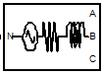
Fig 4.1.Three Phase Source

The Three-Phase Source block implements a balanced three-phase voltage source with internal R-L impedance. The three voltage sources are connected in Y with a neutral connection that can be internally ground.
(ii) VI measurement block
The Three-Phase V-I Measurement block is used to measure three-phase voltages and currents in a circuit. When connected in series with three-phase elements, it returns the three phase-to-ground or phase-to-phase voltages and the three line currents
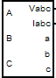
Fig 4.2.Three Phase VI Measurement

(iii) Scope
Display signals generated during a simulation. The Scope block displays its input with respect to simulation time. The Scope block can have multiple axes (one per port); all axes have a common time range with independent y-axes. The Scope allows you to adjust the amount of time and the range of input values displayed. You can move and resize the Scope window and you can modify the Scope's parameter values during the simulation

Fig 4.3.scope

(iv). Three-Phase Series RLC Load
The Three-Phase Series RLC Load block implements a three-phase balanced load as a series combination of RLC elements. At the specified frequency, the load exhibits constant impedance. The active and reactive powers absorbed by the load are proportional to the square of the applied voltage.
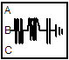
Fig 4.4.Three-Phase Series RLC Load

(v) Three-Phase Breaker block
The Three-Phase Breaker block implements a three-phase circuit breaker where the opening and closing times can be controlled either from an external Simulink signal or from an internal control signal.
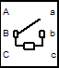
Fig 4.5.Three-Phase Breaker block
(vi) Gain block
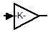
Fig 4.6.Gain block

The Gain block multiplies the input by a constant value (gain). The input and the gain can each be a scalar, vector, or matrix.
MATLAB/SIMULINK RESULTS:
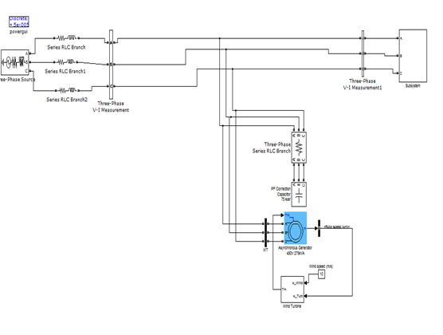Fig .4. 7 Simulink circuit without STATCOM

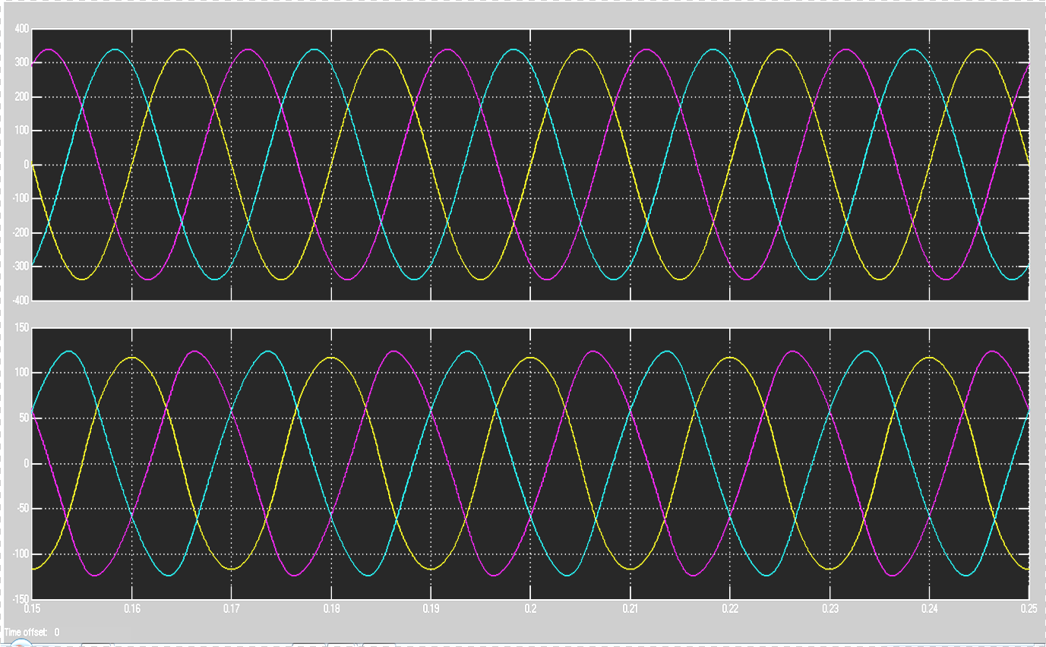
Fig 4. 8: Voltage and current wave forms in source side without STATCOM
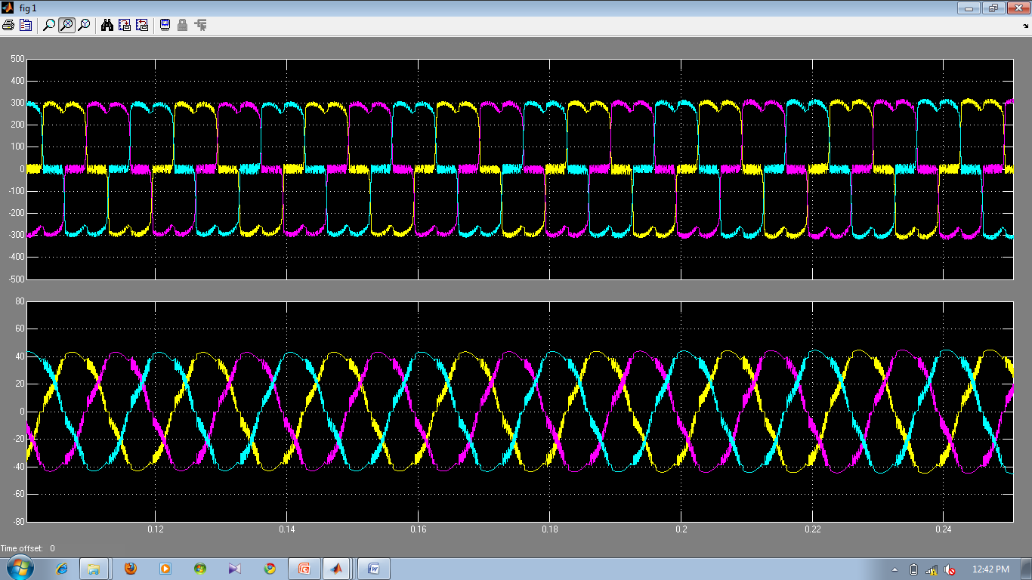
Fig 4. 9: Voltage and current wave forms in load side without STATCOM

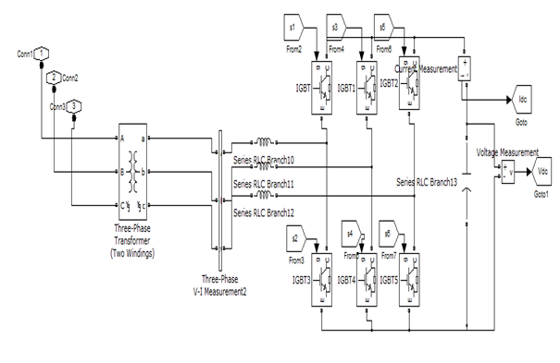
Fig: 4.10 Simulink model of STATCOM
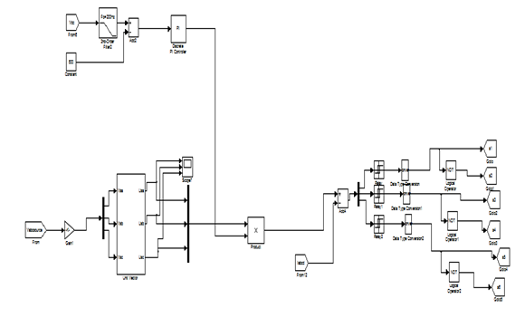
Fig: 4.11 Control Scheme used for SATCOM

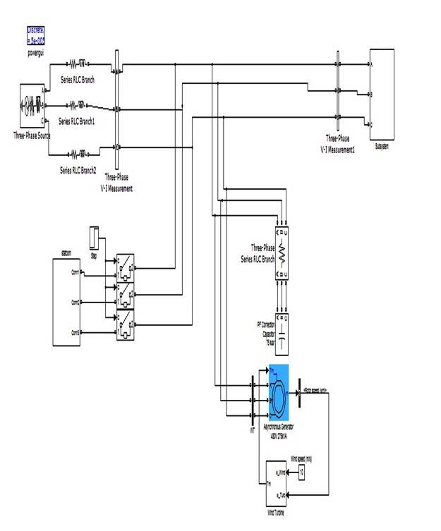
Fig: 4.12 Simulink Circuit of Grid connected system with STATCOM

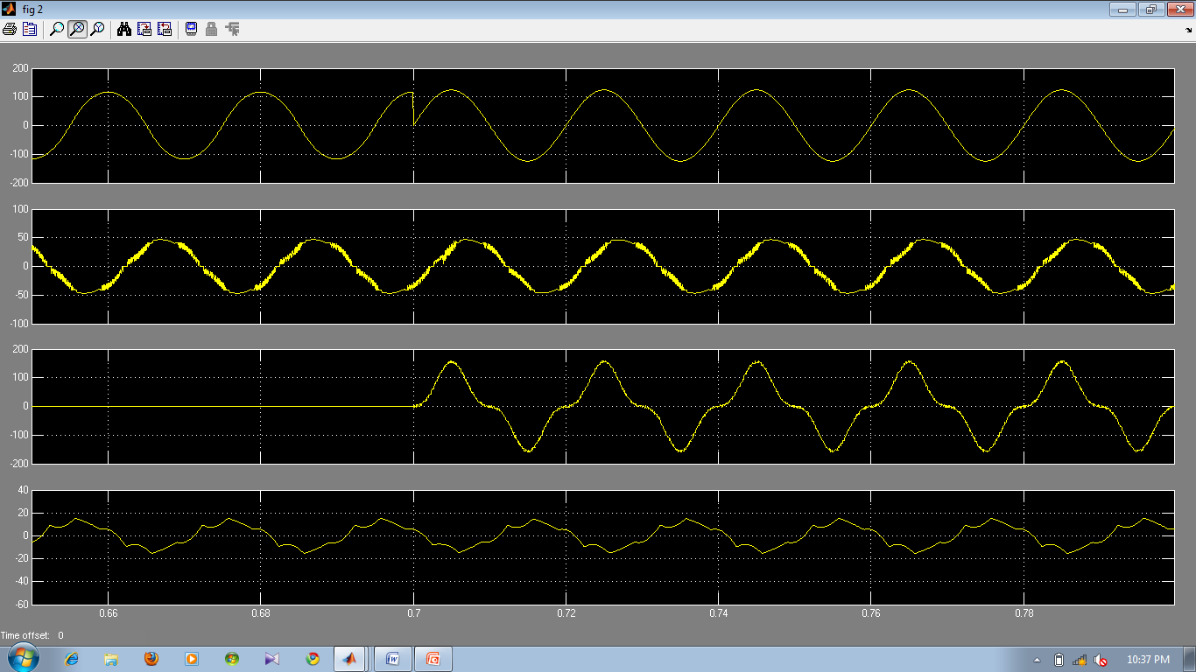

Fig 4.13: (a) Source Current. (b) Load Current. (c) Inverter Injected Current. (d) Wind generator (Induction generator) current

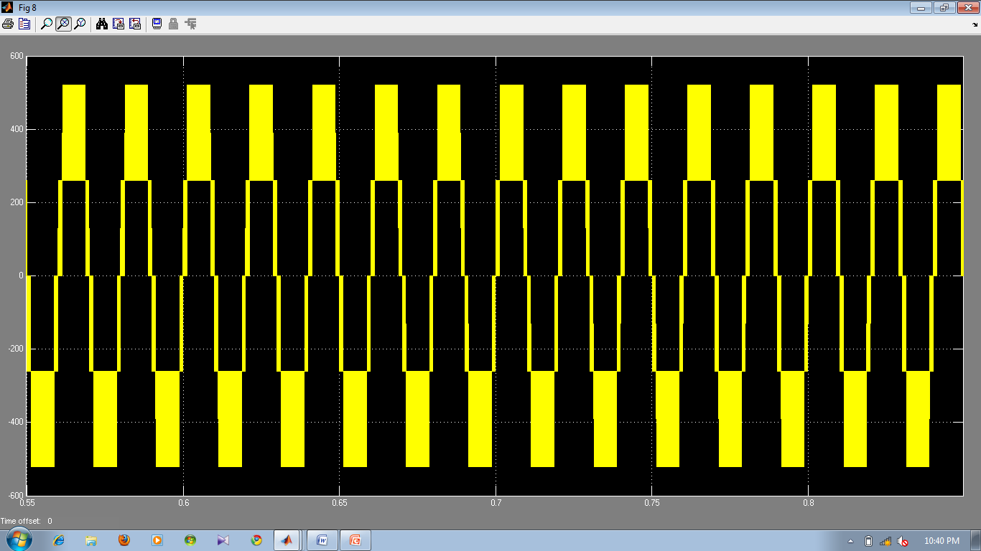
Fig 4.14: Output voltage across STATCOM

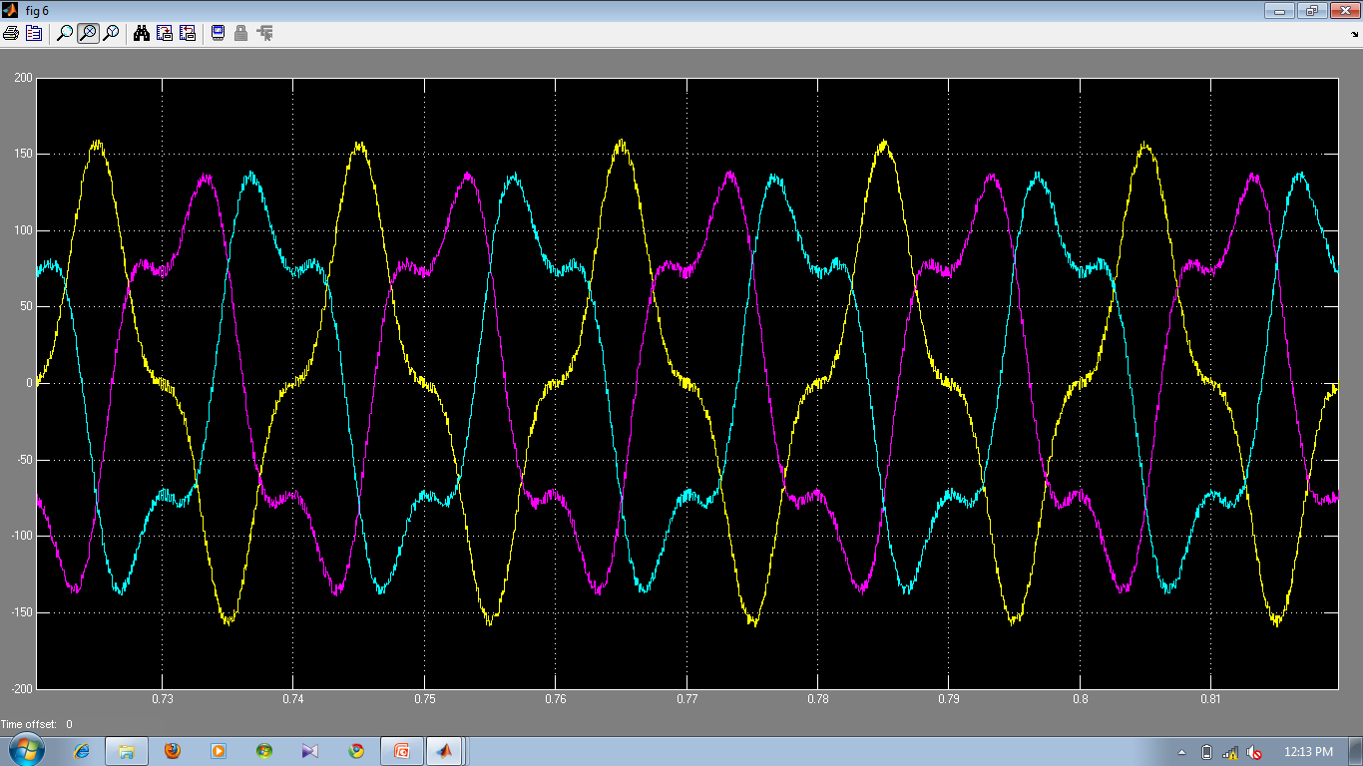
Fig: 4.15 Three Phase Injected Inverter Current

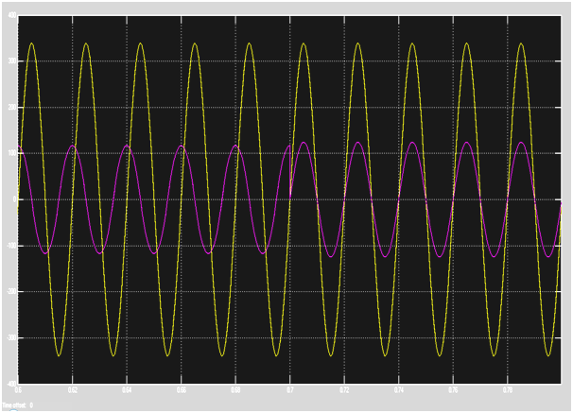
Fig 4.16: Supply Voltage and Current at PCC with STATCOM
Up to 0-0.7 sec the STATCOM is OFF
After 0.7 sec the STATCOM is ON

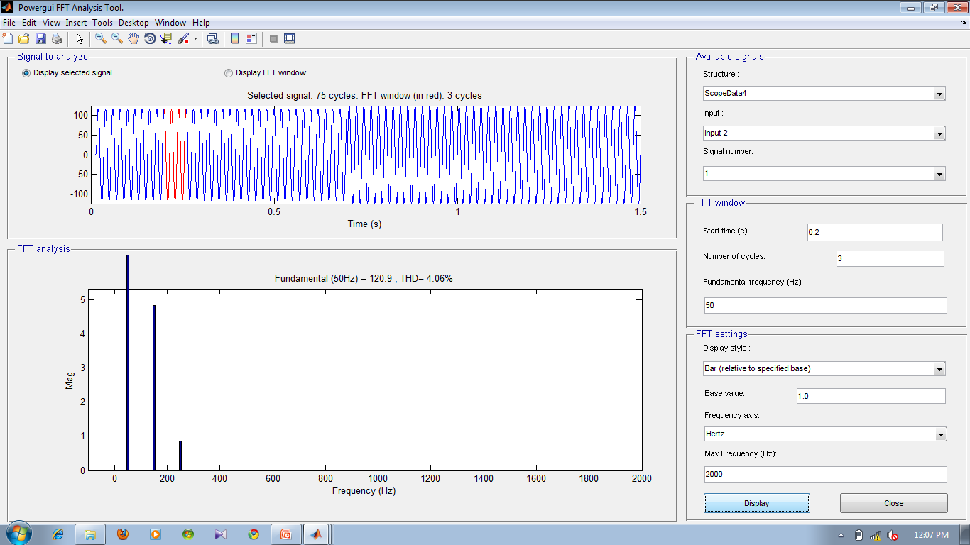
Fig 4.17: (a) Source Current. (b) FFT of source current without STATCOM

In the absence of the STATCOM amount of Total Harmonic Distortion present is about 4.06%. The amount of distortion present will be decreased if we introduce the STATCOM at the PCC.

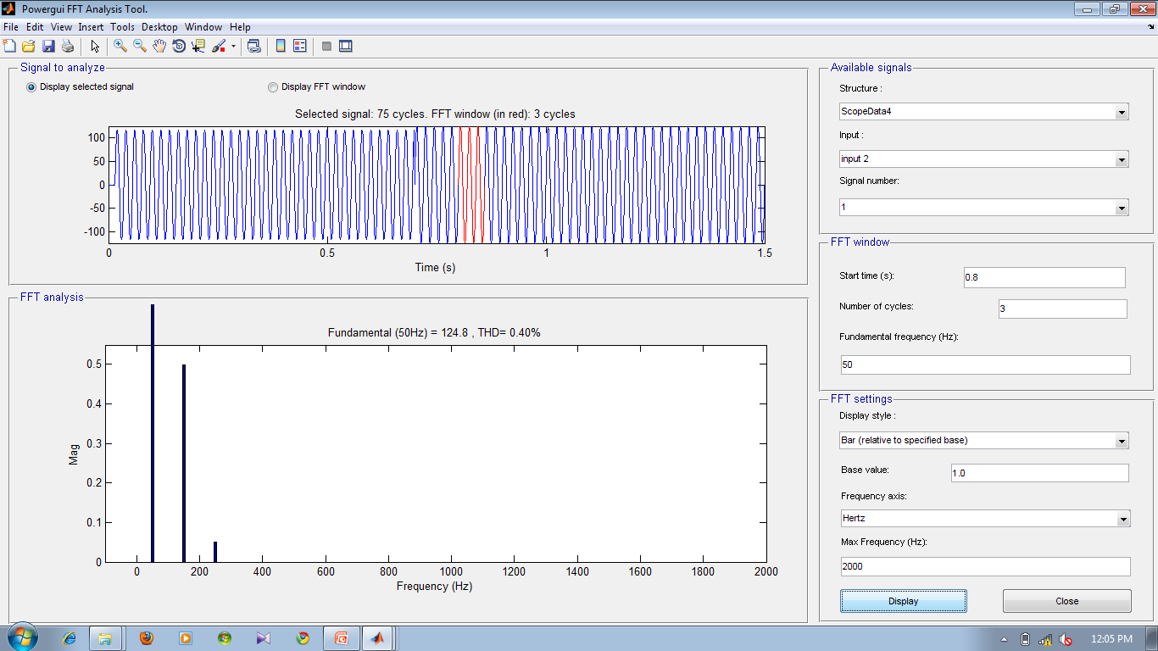

Fig 4.18: (a) Source Current. (b) FFT of source current with STATCOM

The amount of Total Harmonic distortion was decreased from 4.06% to 0.4%. From this we decide that the quality of current is improved.

5. CONCLUSION

This paper presents the STATCOM-based control scheme for reactive power compensation and harmonic reduction in grid connected wind generating system feeding non linear load. The control system for the STATCOM is simulated using MATLAB/SIMULINK. The Simulation results shows the grid voltage and current are in-phase, making the power factor unity, which implies that the reactive power demand of Induction generator and load is no longer, fed by the grid rather it is supplied by the STATCOM. Also the shape of the grid current is almost sinusoidal and the % THD has been improved from 4.06% to 0.40 % after compensation. The proposed control scheme has improved the power quality requirement of a low voltage grid connected wind driven IG system feeding a non-linear load.

REFERENCES
[1] A. Sannino, “Global power systems for sustainable development,” in IEEE General Meeting, Denver, CO, Jun. 2004.

[2] K. S. Hook, Y. Liu, and S. Atcitty, “Mitigation of the wind generation integration related power quality issues by energy storage,” EPQU J., vol. XII, no. 2, 2006.

[3] R. Billinton and Y. Gao, “Energy conversion system models for adequacy assessment of generating systems incorporating wind energy,” IEEE Trans. on E. Conv., vol. 23, no. 1, pp. 163–169, 2008, Multistate.

[4] Wind Turbine Generating System—Part 21, International standard-IEC 61400-21, 2001.

[5]J. Manel, “Power electronic system for grid integration of renewableenergy source: A survey,” IEEE Trans. Ind. Electron., vol. 53, no. 4, pp. 1002–1014, 2006, Carrasco.

[6] M. Tsili and S. Papathanassiou, “A review of grid code technology requirements for wind turbine,” Proc. IET Renew.power gen., vol. 3, pp. 308–332, 2009.

[7] S. Heier, Grid Integration of Wind Energy Conversions. Hoboken, NJ: Wiley, 2007, pp. 256–259.

[8] J. J. Gutierrez, J. Ruiz, L. Leturiondo, and A. Lazkano, “Flicker measurement system for wind turbine certification,” IEEE Trans. Instrum. Meas., vol. 58, no. 2, pp. 375–382, Feb. 2009.

[9] Indian Wind Grid Code Draft report on, Jul. 2009, pp. 15–18, C-NET.

[10] C. Han, A. Q. Huang, M. Baran, S. Bhattacharya, and W. Litzenberger, “STATCOM impact study on the integration of a large wind farm into a weak loop power system,” IEEE Trans. Energy Conv., vol. 23, no. 1, pp. 226–232, Mar. 2008.

[11] D. L. Yao, S. S. Choi, K. J. Tseng, and T. T. Lie, “A statistical approach to the design of a dispatchable wind power—Battery energy storage system,” IEEE Trans. Energy Conv., vol. 24, no. 4, Dec. 2009.

[12] F. Zhou, G. Joos, and C. Abhey, “Voltage stability in weak connection wind farm,” in IEEE PES Gen. Meeting, 2005, vol. 2, pp. 1483–1488.

[13] T. Kinjo and T. Senjyu, “Output leveling of renewable energy by electric double layer capacitor applied for energy storage system,” IEEE Trans. Energy Conv., vol. 21, no. 1, Mar. 2006.

[14] R. S. Bhatia, S. P. Jain, D. K. Jain, and B. Singh, “Battery energy storage system for power conditioning of renewable energy sources,” in Proc. Int. Conf. Power Electron Drives System, Jan. 2006, vol. 1, pp. 501–506.

[15] S. W. Mohod and M. V. Aware, “Grid power quality with variable speed wind energy conversion,” in Proc. IEEE Int. Conf. Power Electronic Drives and Energy System (PEDES), Delhi, Dec. 2006.

[16] Fu. S. Pai and S.-I. Hung, “Design and operation of power converter for microturbine powered distributed generator with capacity expansion capability,” IEEE Trans. Energy Conv., vol. 3, no. 1, pp. 110–116, Mar. 2008.

[17] J. Zeng, C. Yu, Q. Qi, and Z. Yan, “A novel hysteresis current control for active power filter with constant frequency,” Elect. Power Syst. Res., vol. 68, pp. 75–82, 2004.

[18] M. I. Milands, E. R. Cadavai, and F. B. Gonzalez, “Comparison of control strategies for shunt active power filters in three phase four wire system,” IEEE Trans. Power Electron., vol. 22, no. 1, pp. 229–236, Jan. 2007.

[19] S. W. Mohod and M. V. Aware, “Power quality issues & it’s mitigation technique in wind energy conversion,” in Proc. of IEEE Int. Conf. Quality Power & Harmonic, Wollongong, Australia, 2008.

Base Paper:

S. W. Mohod and M. V. Aware, “A STATCOM-Control Scheme for Grid Connected
Wind Energy System for Power Quality Improvement”, IEEE Systems Journal, Vol. 4, No. 3, September 2010.

